# CS 255 System Design Document Template

This template lays out all the different sections that you need to complete for Project Two. Each section has guidance to prompt your thinking. You will need to continually reference the interview transcript as you work to make sure that you are addressing your client’s needs. There is no required length for the final document. Instead the goal is to complete each section based on what your client’s needs are. Remove this note when you are finished, and replace all bracketed text with the relevant information.

## UML Diagrams

### UML Use Case Diagram

*[In Module Six, you were asked to complete a use case diagram based on your system design. If you would like to make any adjustments to your diagram, please do so. Please insert your use case diagram here. Check to make sure that you included appropriate components and symbols and that your design meets the client’s needs.]*

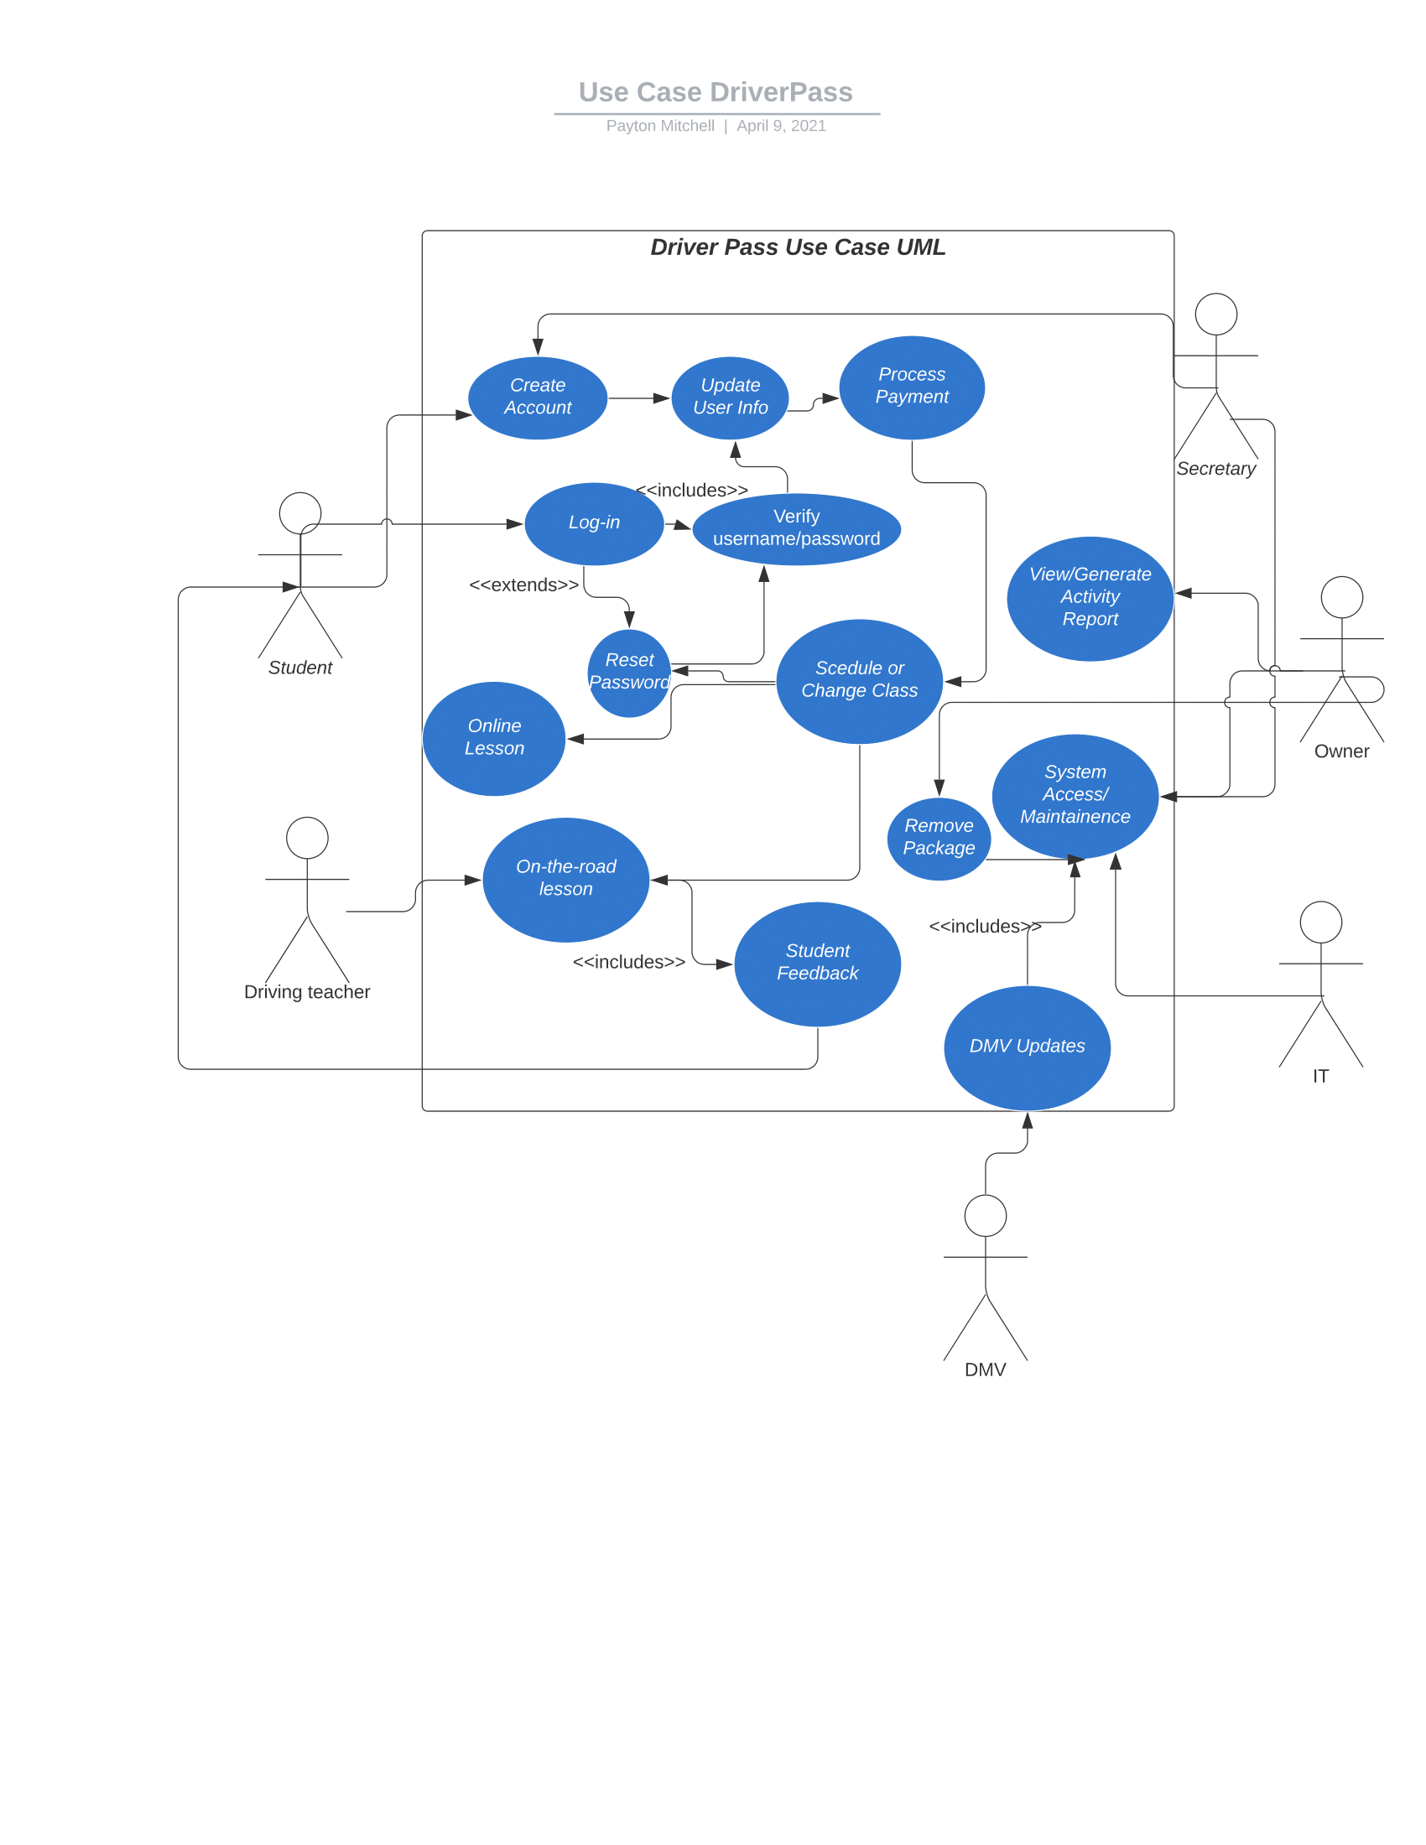

### UML Activity Diagrams

*[You were asked to choose* ***two*** *use cases and create* ***two*** *activity diagrams, one for each use case. Please insert* ***both*** *of your activity diagrams here. Check to make sure that you included appropriate components and symbols and that your design meets the client’s needs.]*

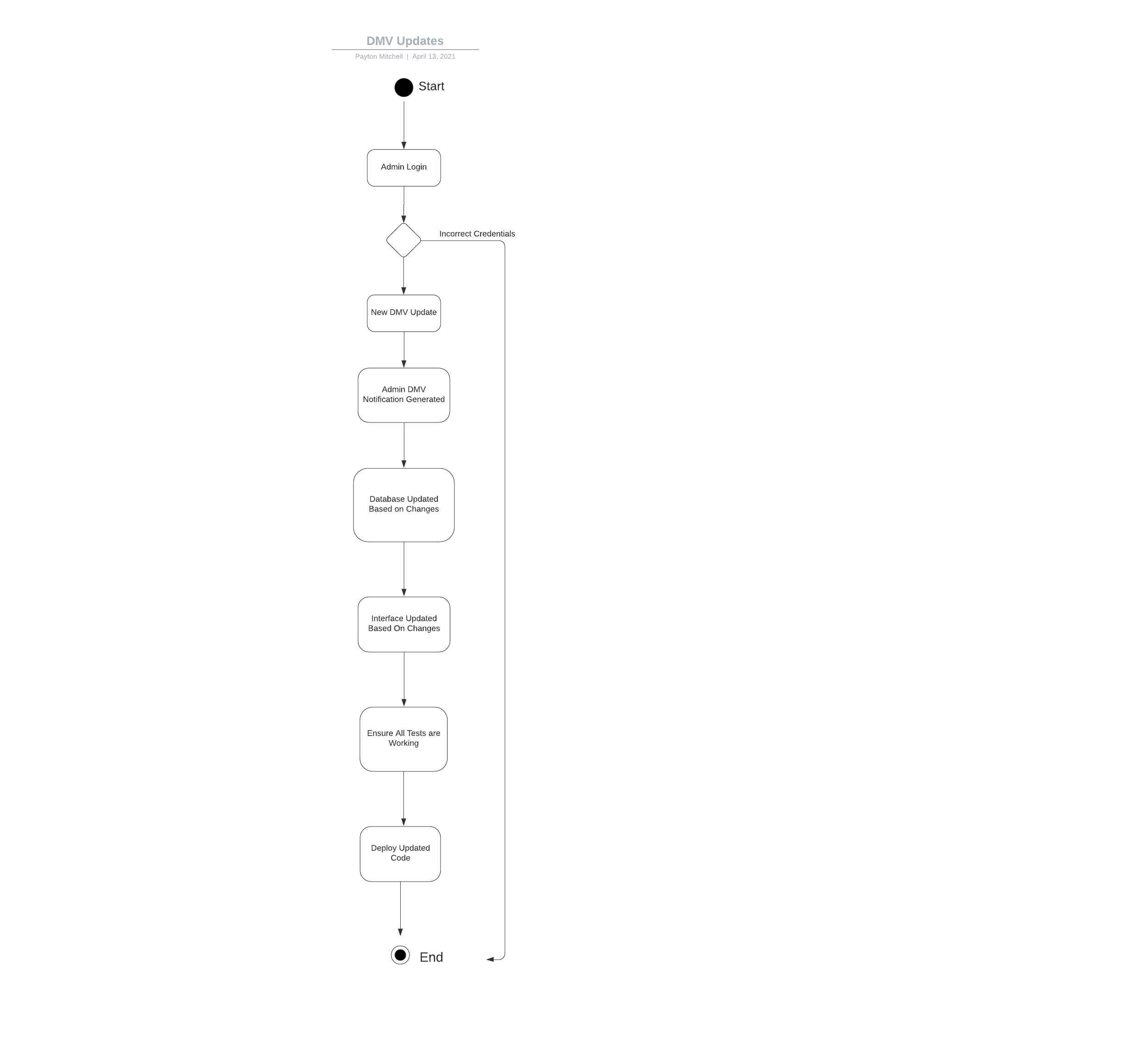

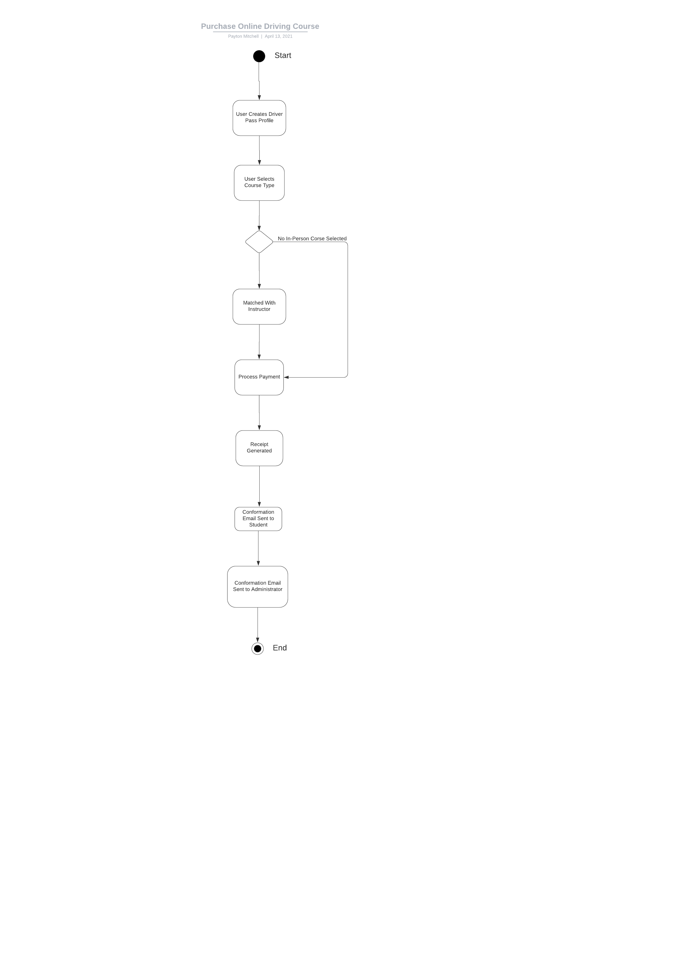

### UML Sequence Diagram

*[You were asked to create a sequence diagram based on* ***one*** *of the use cases you chose. Please insert your sequence diagram here. Check to make sure that you included appropriate components and symbols and that your design meets the client’s needs.]*

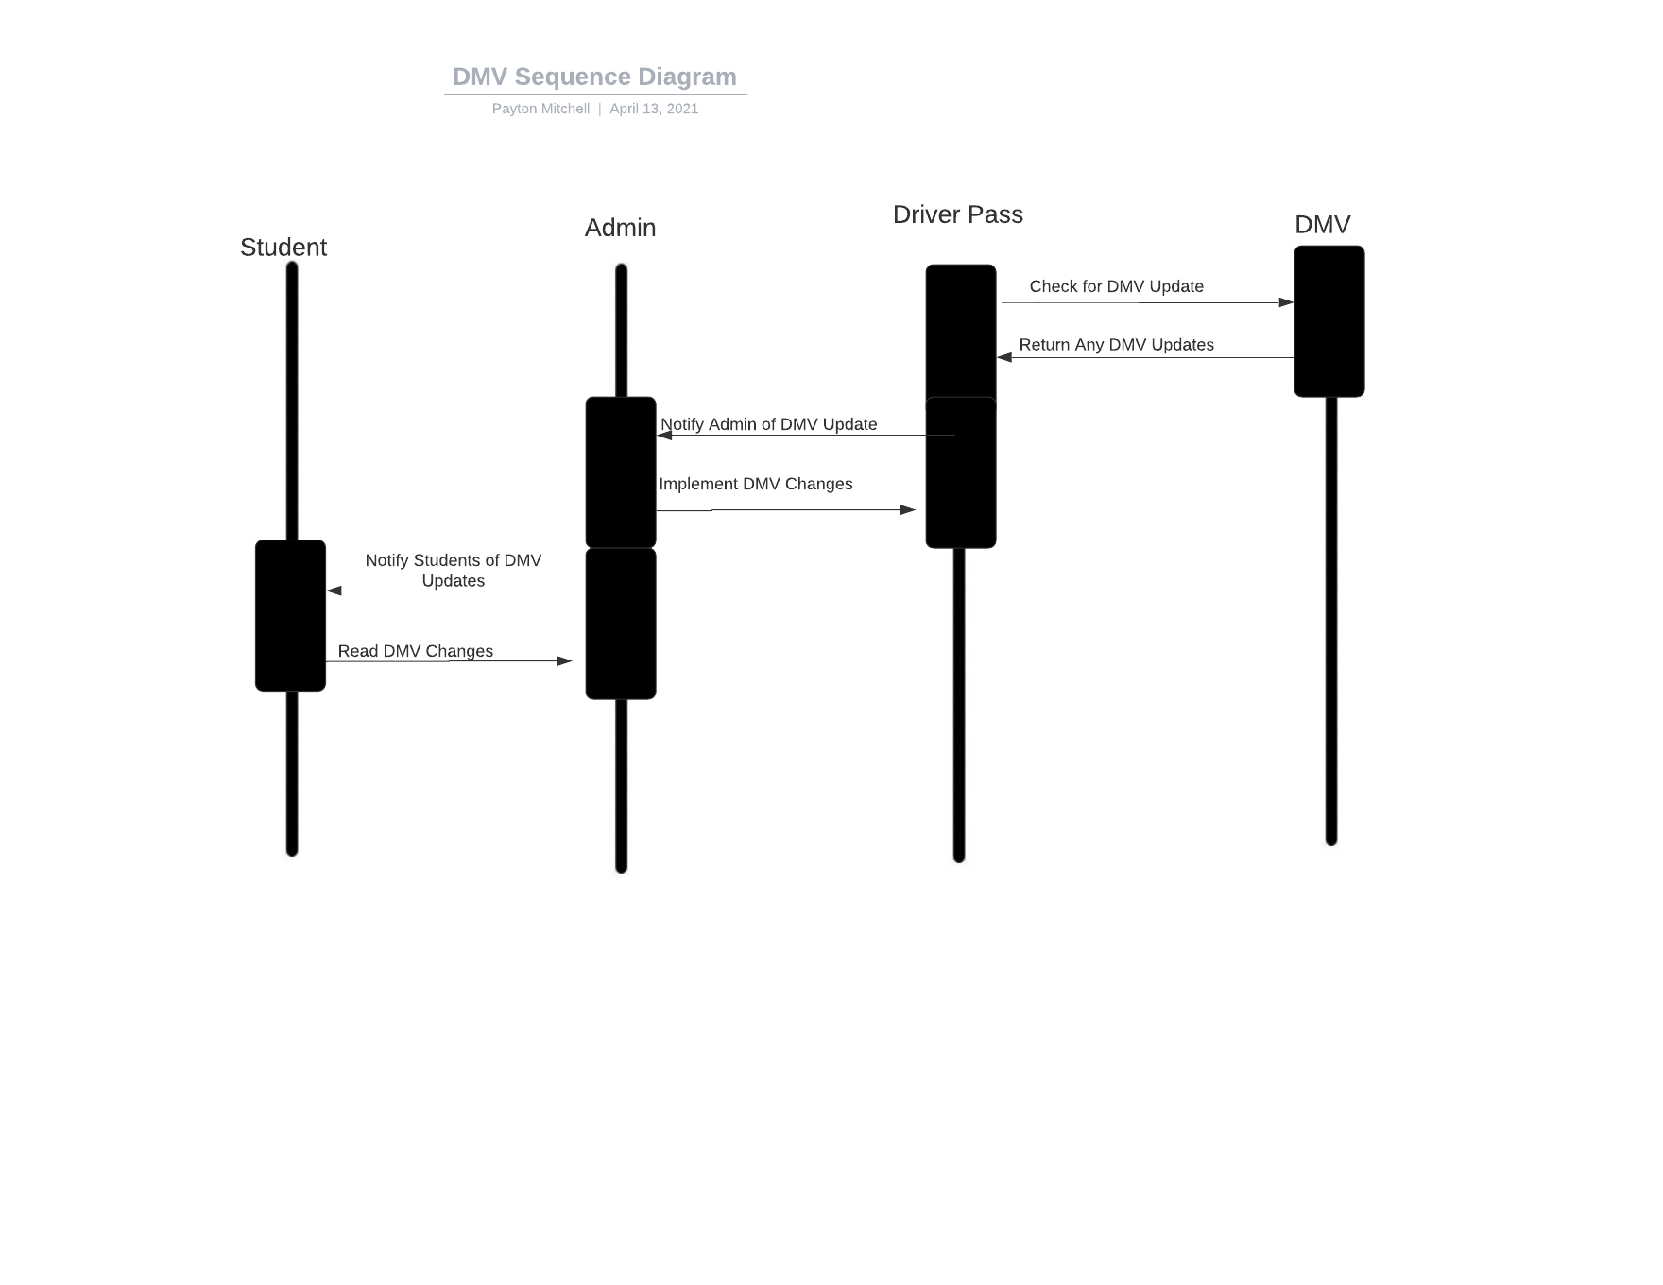

### UML Class Diagram

*[You were asked to create a class diagram based on the different classes and attributes needed for your system design. You are* ***not*** *required to include methods, but you may if you wish. Please insert your class diagram here. Check to make sure that you included appropriate components and symbols and that your design meets the client’s requirements.]*

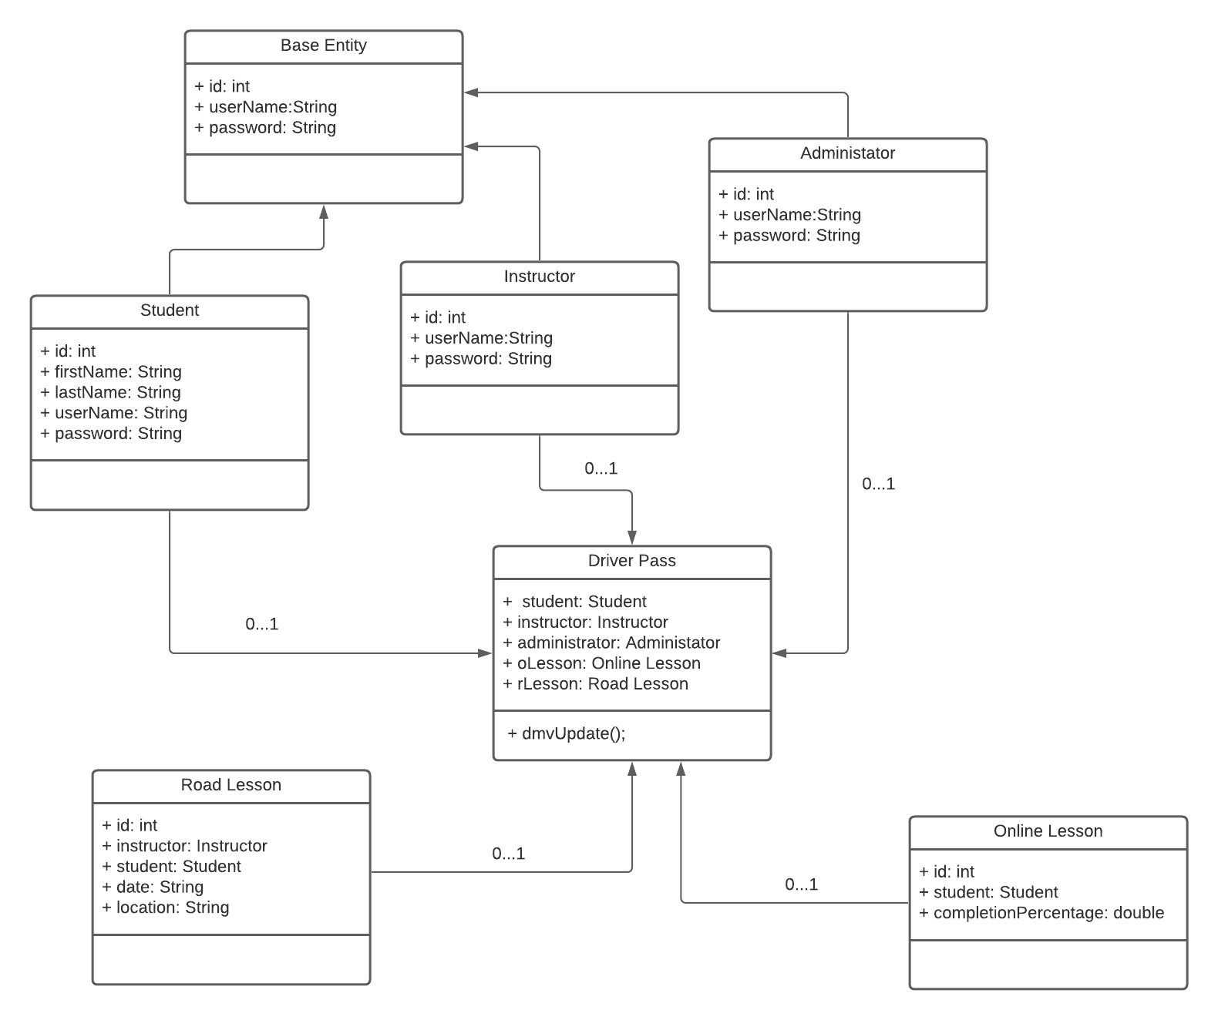

## Technical Requirements

*[Based on the diagrams you have created, describe the technical requirements of your system. These requirements should address the required hardware, software, tools, and infrastructure necessary for your system design.]*

*Representing Driver Pass through these diagrams really gives us a deep understanding of the system. We understand how the user will interact with the system via the graphical interface and understand all the individual parts that make up the Driver Pass system. Now that we understand the Driver Pass system as a whole, we need to start considering what other resources we need. In terms of hardware, we will use cloud servers so that we do not have to worry as much about security and overloading our servers. For the software developers that make the application we will need individual laptops that they can all access the code base from. Depending on whether the owner wants us to work form an office or home we may need to have an office router with a very fast internet connection. If we were to go with a remote environment, I feel that we would need to ensure that all employees have a good internet connection. Perhaps, we could supply our software engineers with routers so that we do not have to deal with connection problems. In terms of the needed software, we will need a code editor like Eclipse or IntelliJ. For team meetings, we could use Microsoft teams so that we could use the screen sharing function whenever needed. This would help our less experienced engineers be able to solve bugs easier with our senior software engineers. We know that we will need to test our application and a program that really helps us maintain the tests of our program are continuous integration platforms. An example of this includes Circle Ci, which would help in terms of ensuring all our test pass. Whenever the code is changed and the result is a failure in one of our tests, we will get an email with the stack trace. This I feel will help in the long run and making sure our program is working and secure. Depending on the cloud service we decide to use we will need an account for all engineers on the service. Examples of these include Microsoft Azure and Amazon Web Services. We will also need driving instructors for the in-person lessons and also vehicles for the students to use. Because they are student drivers, I would recommend that we get cars that allow the driving instructor to brake whenever necessary.*